Foodora Eats – Restaurant Discovery & Customer Experience Analysis
A Data Analytics Case Study

1. Team & Contributions
This case study was completed as part of a team-based analytics challenge.
Team Members & Roles
- Pavithran R – Data analysis, visualization, insight generation.
- Kabila S – Data review and discussion.

2. Business Problem & Context
Foodora Eats is a restaurant discovery and food delivery platform operating across multiple cities. Customers rely on the platform to explore restaurants, compare ratings, browse cuisines, and decide between dine-in or online delivery options.
Despite high platform activity, Foodora Eats faces challenges related to inconsistent customer experience. Some cities have a large number of restaurants but show uneven quality in customer ratings. Certain cuisines attract strong customer interest but receive lower satisfaction scores. Additionally, restaurant performance varies significantly across localities within the same city, and delivery availability is not consistent across markets.
These issues affect customer trust, restaurant visibility, and overall engagement on the platform. The purpose of this analysis is to identify where these inconsistencies occur and understand the factors influencing restaurant performance across cities, localities, cuisines, and delivery availability.

3. Data Overview & Preparation (WHAT)
3.1 Dataset Overview
The dataset contains restaurant-level information across multiple cities, including details related to location, cuisine offerings, customer ratings, votes, and service availability.
Key attributes used in this analysis include:
- City and locality.
- Cuisine types.
- Aggregate rating and number of votes.
- Online delivery and delivery availability indicators.
The analysis focused on attributes directly connected to customer experience and restaurant performance.
3.2 Data Cleaning & Assumptions
Before proceeding with the analysis, the dataset was cleaned and prepared with a focus on analytical clarity and interpretability rather than excessive transformation.
Key data preparation decisions included:
- Missing values in the cuisine column were handled to maintain continuity in cuisine-level analysis and avoid excluding relevant restaurants
- Only columns directly related to customer experience and restaurant performance were retained, reducing noise from non-essential attributes
- Restaurants offering multiple cuisines were treated as a single entity to preserve the integrity of aggregate ratings and vote counts, avoiding artificial splitting of customer feedback
- No complex feature engineering was applied, as the objective was to identify clear descriptive and diagnostic patterns rather than predictive outcomes
These cleaning and preparation decisions were made deliberately to ensure that the insights reflect real-world platform behavior and can be easily interpreted by non-technical stakeholders.

4. Analysis Approach (HOW)
The analysis was structured around the core business challenges rather than exploring all available variables. The focus was placed on dimensions that directly influence restaurant discovery and customer satisfaction.
The approach included:
- City-level analysis to compare restaurant density with average ratings.
- Locality-level analysis to understand performance variation within cities.
- Cuisine-level analysis to compare customer interest (votes) with satisfaction (ratings).
- Delivery availability analysis to evaluate its relationship with customer ratings.
The analysis uses descriptive and diagnostic analytics to understand what is happening on the platform and why certain patterns may exist. Excel was used for data preparation and aggregation, while Power BI was used for visual analysis and storytelling.

5. Key Insights (WHAT)
Insight 1: High restaurant density in cities does not ensure consistent customer satisfaction (City vs Average Rating – Top & Bottom Cities by Restaurant Count)

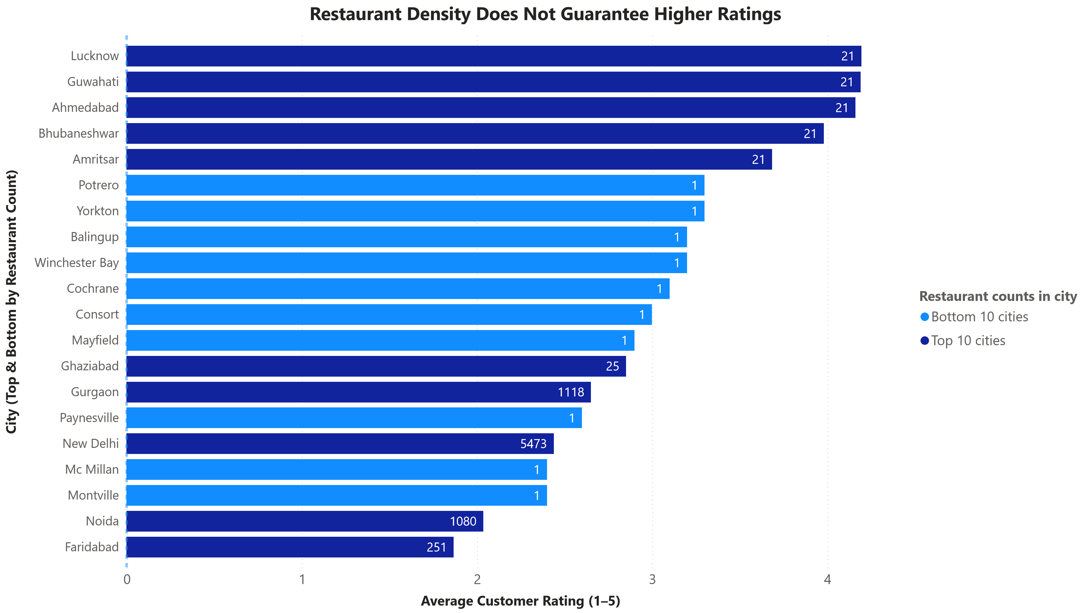

Cities with a high concentration of restaurants exhibit mixed average ratings. While these cities provide customers with more choices, the overall customer satisfaction does not consistently improve with increased restaurant density. This highlights that availability alone is insufficient and points to quality variation across restaurants within high-activity cities.

Insight 2: Significant performance variation exists at the locality level within the same city (Locality vs Average Rating – Top & Bottom Localities)

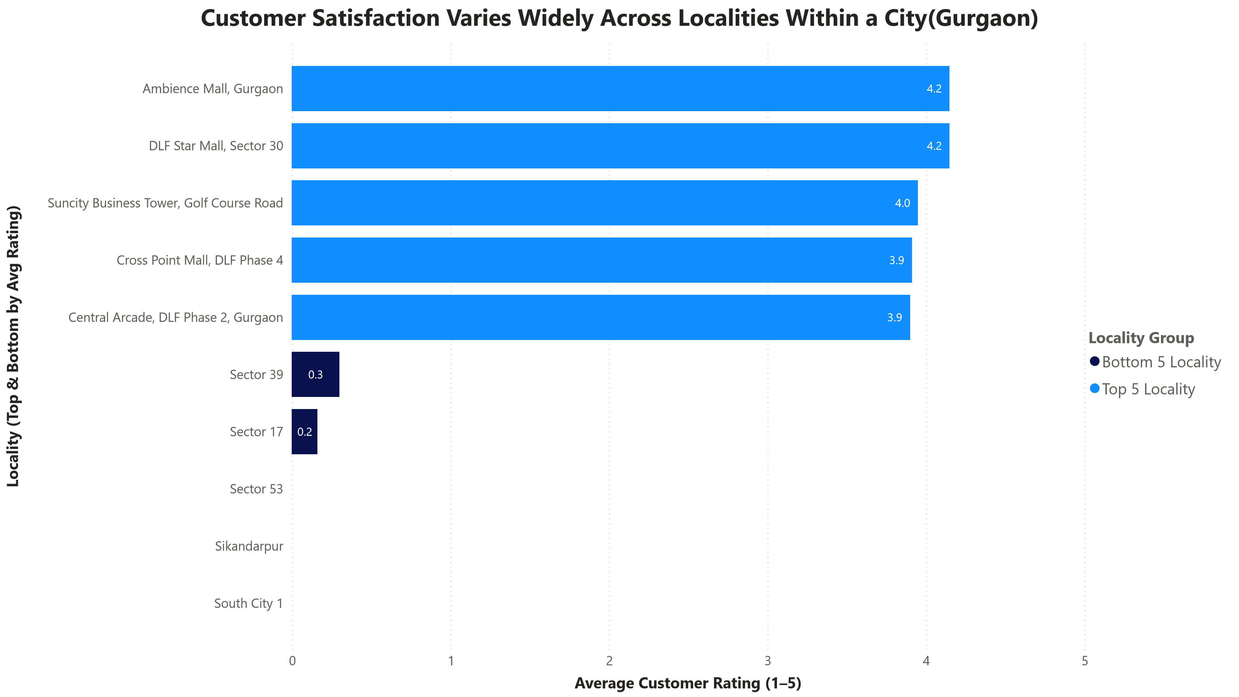

Within individual cities, restaurant performance varies widely across localities. Some localities consistently achieve higher average ratings, while others underperform despite being part of the same urban market. This indicates that city-level averages can mask localized quality issues and emphasizes the importance of locality-level performance monitoring.

Insight 3: High-demand cuisines show clear gaps between popularity and customer satisfaction (Cuisine – Votes vs Average Rating)

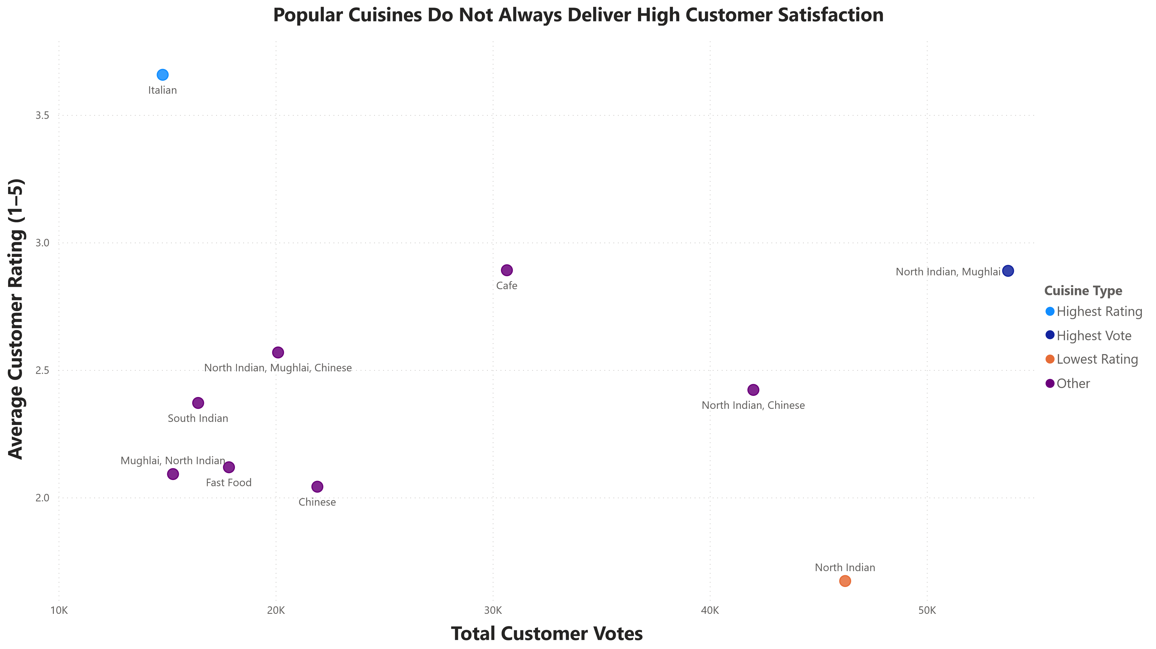

Several cuisines attract a high volume of customer votes, reflecting strong demand and popularity. However, these cuisines do not always receive correspondingly high average ratings. This points to clear quality inconsistency across restaurants offering the same cuisine, where popularity is driven by demand rather than reliable customer satisfaction.

Insight 4: Delivery-ready restaurants tend to perform better in customer ratings (Delivery Status vs Average Rating)

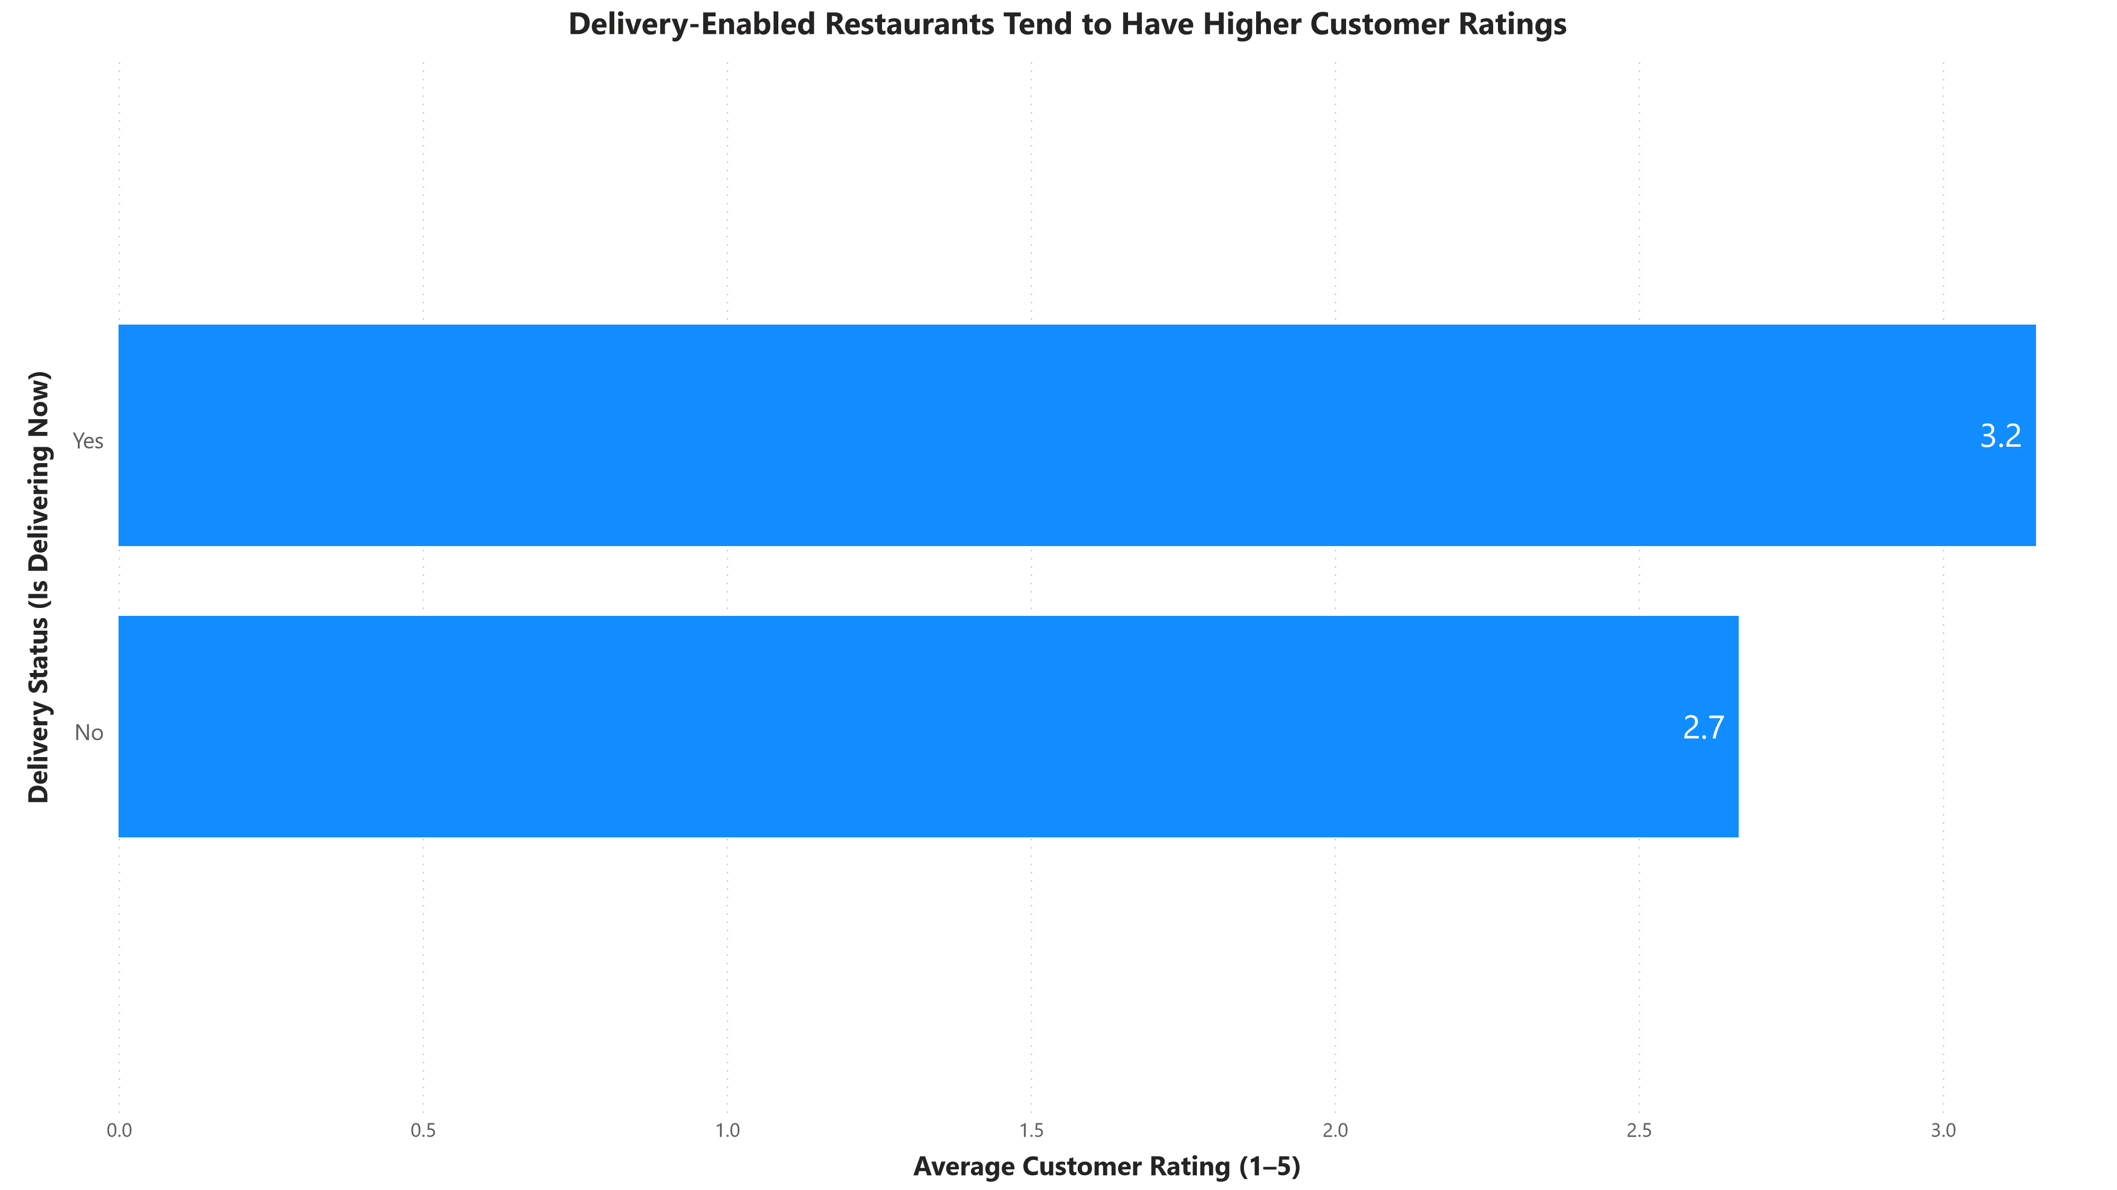

Restaurants with active delivery availability generally demonstrate higher average ratings compared to those without delivery services. This suggests that delivery readiness is associated with better operational performance or stronger alignment with customer preferences, contributing positively to overall customer experience.

6️. Recommendations
- Introduce locality-level quality monitoring by tracking average ratings and vote volumes to identify underperforming areas within cities.
- Establish cuisine-specific quality benchmarks for high-demand cuisines by monitoring rating trends and customer feedback patterns.
- Improve visibility of high-rated restaurants in high-density cities.
- Encourage delivery readiness by prioritizing delivery-enabled restaurants in discovery rankings and supporting operational improvements.
7️. Conclusion
This analysis shows that customer satisfaction on Foodora Eats is driven not only by availability, but by consistency across cities, localities, cuisines, and delivery services. By shifting focus from volume-driven growth to quality-driven discovery, the platform can improve customer trust, engagement, and long-term performance.
8️. Tools & Skills Used
- Excel – data cleaning and pivot-based analysis.
- Power BI – visualization and insight communication.
- Descriptive & diagnostic analytics.
- Data storytelling.

